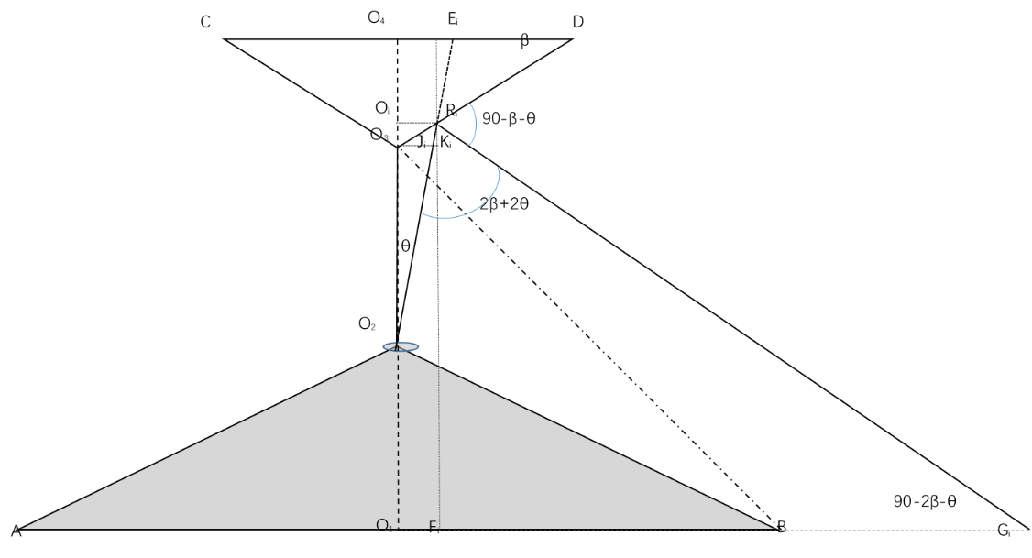
Any incident ray O₂R₁, strikingthe cone surface O₃D at point R_{i}, is reflected as R_{i}Gi, reaching the ground at point G_{i}; Needs to calculate the length of O₁G_{i}: $O_{1}G_{i}=O_{1}F_{i}+F_{i}G_{i}$ (1)
$O_{1}F_{i}=O_{i}R_{i}=O_{3}J_{i}+J_{i}K_{i}=O_{2}O_{3}\tan{θ}+J_{i}K_{i}={O_{2}O_{3}\tan{θ}+R}_{i}K_{i}\tan{θ}$ (2)
$R_{i}K_{i}=O_{i}O_{3}=O_{i}R_{i}\tan{β}$ (3)
(3) substituting into (2) gives: $O_{i}R_{i}={O_{2}O_{3}\tan{θ}+R}_{i}K_{i}\tan{θ}=O_{2}O_{3}\tan{θ}+O_{i}R_{i}\tan{β}\tan{θ}$ (4)
O₂O₃ is known, O_{i}R_{i} can be determined from equation (4): $O_{i}R_{i}={O_{2}O_{3}\tan{θ}}/{1-\tan{β}\tan{θ}}$ (5)
From (3) and (5), $R_{i}K_{i}=O_{i}R_{i}\tan{β}=\left({O_{2}O_{3}\tan{θ}}/{1-\tan{β}\tan{θ}}\right)\tan{β}={O_{2}O_{3}\tan{θ}\tan{β}}/{1-\tan{β}\tan{θ}}$ (6)
From ΔR_{i}F_{i}G_{i} we have $F_{i}G_{i}={R_{i}F}_{i}\tan\left(90-2β-θ\right)=({R_{i}K}_{i}+K_{i}F_{i})\tan\left(90-2β-θ\right)=\left({O_{2}O_{3}\tan{θ}\tan{β}}/{1-\tan{β}\tan{θ}}+O_{2}O_{3}+O_{2}O_{1}\right)\cot{(2β+θ)}$ (7)
$O_{1}G_{i}=O_{1}F_{i}+F_{i}G_{i}=O_{i}R_{i}+F_{i}G_{i}=\left({O_{2}O_{3}\tan{θ}}/{1-\tan{β}\tan{θ}}\right)+\left({O_{2}O_{3}\tan{θ}\tan{β}}/{1-\tan{β}\tan{θ}}+O_{2}O_{3}+O_{2}O_{1}\right)\cot{(2β+θ)}=O_{2}O_{3}\frac{\tan{θ}\left(1+\tan{β\cot{(2β+θ)}}\right)}{1-\tan{β}\tan{θ}}+\left(O_{2}O_{3}+O_{2}O_{1}\right)\cot{(2β+θ)}=O_{2}O_{3}\frac{\tan{θ}\left(1+\tan{β}\cot\left(2β+θ\right)\right)}{1-\tan{β}\tan{θ}}+\left(O_{3}O_{1}\right)\cot{(2β+θ)}$ (8)
From equation (8), it can be seen that O₁O₂ represents the height of the robot, O₂O₃ represents the height of the vertex of the panoramic conical mirror relative to the installation point，O₁O₃ represents the height of the vertex of the conical mirror, and β is the complementary angle of the cone angle of the conical mirror, all of which are known quantities. θ is the variable.

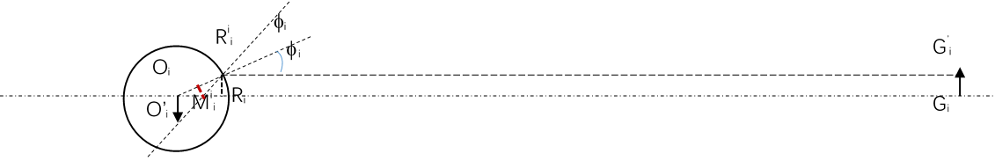

Along the horizontal y-direction (perpendicular to the optical axis), an obstacle located at G_{i} with the width G_{i}G‘_{i} forms a circluar image; the circle size corresponds to the radius O_{i}R_{i} associated with the incident angle θ in the previous figure. The image of the obstacle of width G_{i}G‘_{i} is O_{i}O‘_{I}, whose magnitude is computed as follows:
The radial incident angle for the obstacle of width G_{i}G‘_{i} is φ_{i}, which is computed as follows:
$φ_{i}=\sin^{-1}\left({G_{i}G_{i}^{'}}/{O_{i}R_{i}}\right)=\sin^{-1}\left({G_{i}G_{i}^{'}}/{\left({O_{2}O_{3}\tan{θ}}/{1-\tan{β}\tan{θ}}\right)}\right)$ (9)
$O_{i}O_{i}^{'}=O_{i}M_{i}^{'}\tan{∆O_{i}M_{i}^{'}O_{i}^{'}}=O_{i}M_{i}^{'}\tan{2φ_{i}}=\left({\frac{O_{i}R_{i}}{2}}/{\cos{φ_{i}}}\right)\tan{2φ_{i}}=\left({\left({O_{2}O_{3}\tan{θ}}/{1-\tan{β}\tan{θ}}\right)}/{2\cos{φ_{i}}}\right)\tan{2φ_{i}}=\frac{\left({O_{2}O_{3}\tan{θ}}/{1-\tan{β}\tan{θ}}\right)\tan{2φ_{i}}}{2\cos{φ_{i}}}$ (10)
$O_{i}O_{i}^{'}=\frac{\left({O_{2}O_{3}\tan{θ}}/{1-\tan{β}\tan{θ}}\right)\tan{2φ_{i}}}{2\cos{φ_{i}}}=\frac{\left({O_{2}O_{3}\tan{θ}}/{1-\tan{β}\tan{θ}}\right)\sin{2φ_{i}}}{2\cos{φ_{i}}\cos{2φ_{i}}}=\frac{\left({O_{2}O_{3}\tan{θ}}/{1-\tan{β}\tan{θ}}\right)2\sin{φ_{i}}\cos{φ_{i}}}{2\cos{φ_{i}}\left(1-2{\left(\sin{φ_{i}}\right)}^{2}\right)}=\frac{\left({O_{2}O_{3}\tan{θ}}/{1-\tan{β}\tan{θ}}\right)\sin{φ_{i}}}{\left(1-2{\left(\sin{φ_{i}}\right)}^{2}\right)}$ (11)
Substitute (9) into (11) gives
$O_{i}O_{i}^{'}=\frac{\left({O_{2}O_{3}\tan{θ}}/{1-\tan{β}\tan{θ}}\right)\sin{φ_{i}}}{\left(1-2{\left(\sin{φ_{i}}\right)}^{2}\right)}=\frac{\left({O_{2}O_{3}\tan{θ}}/{1-\tan{β}\tan{θ}}\right)\left[{G_{i}G_{i}^{'}}/{\left({O_{2}O_{3}\tan{θ}}/{1-\tan{β}\tan{θ}}\right)}\right]}{\left(1-2{\left({G_{i}G_{i}^{'}}/{\left({O_{2}O_{3}\tan{θ}}/{1-\tan{β}\tan{θ}}\right)}\right)}^{2}\right)}=\frac{G_{i}G_{i}^{'}}{1-2{\left(\frac{G_{i}G_{i}^{'}}{O_{2}O_{3}}\right)}^{2}{\left(\frac{1-\tan{β}\tan{θ}}{\tan{θ}}\right)}^{2}}$ (12)
From equation (12), O₂O₃ represents the height of the vertex of the panoramic conical mirror relateive to its installation point, G_{i}G‘_{i} represents the horizontal width of the obstacle, β is the complementary angle of the cone angle of the conical mirror; all of these are known quantities. θ is the variable. Thus for any direction θ, the conical image width of the obstacle with hirizontal width G_{i}G‘_{i} is O_{i}O‘_{i}.

G_{i}
O_{i}
G’_{i}
R_{i}
O’_{i}
R^{i}_{i}
M^{i}_{i}
φ_{i}
φ_{i}
O₄
O₃
O₂
O₁
C
D

A
B

R_{i}
O_{i}
J_{i}
K_{i}
E_{i}
F_{i}
G_{i}
θ
β
90-β-θ
90-2β-θ
2β+2θ

